INDEX

|  |  |
| --- | --- |
| **Sr.no.** | **Practical** |
| **1** | **Design an Expert system using AIML.** |
| **2** | **Design a bot using AIML.** |
| **3** | **Implement Bayes Theorem using Python.** |
| **4** | **Implement Conditional Probability And Joint Probability using Python.** |
| **5** | **Write a program to implement Rule Based System.** |
| **6** | **Design a Fuzzy based application using Python.** |
| **7** | **Write an application to simulate supervised and un-supervised learning model.** |
| **8** | **Write an application to implement clustering algorithm.** |
| **9** | **Write an application to implement BFS algorithm.** |
| **10** | **Write an application to implement DFS algorithm.** |

# PRACTICAL:1

AIM: Design An Expert System Using AIML. Code:

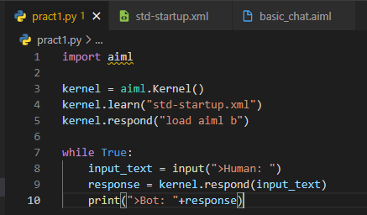

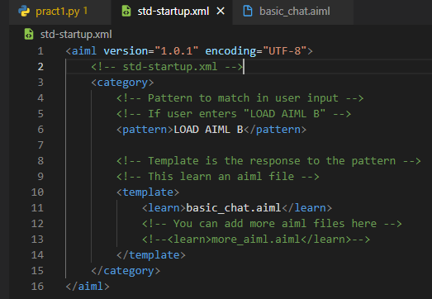

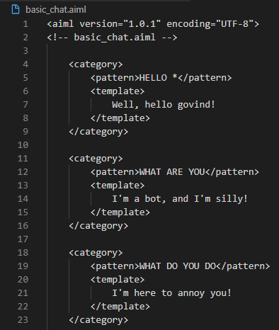

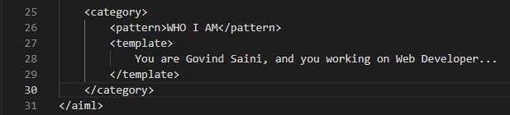

Ouput:

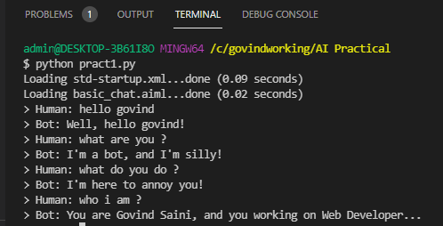

# PRACTICAL:2

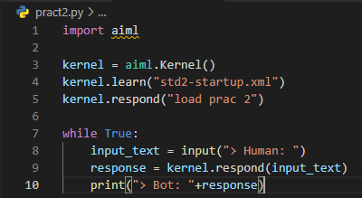AIM : Design A Bot Using AIML. Code:

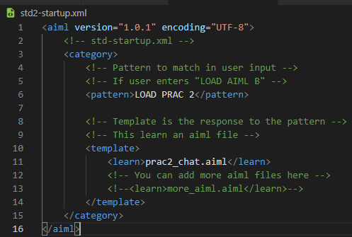

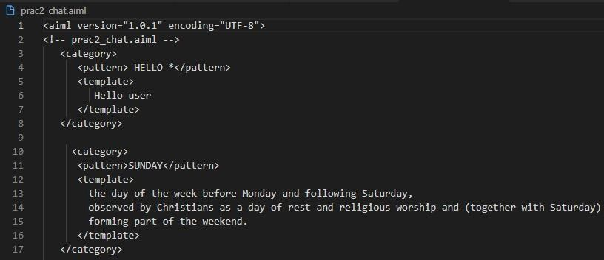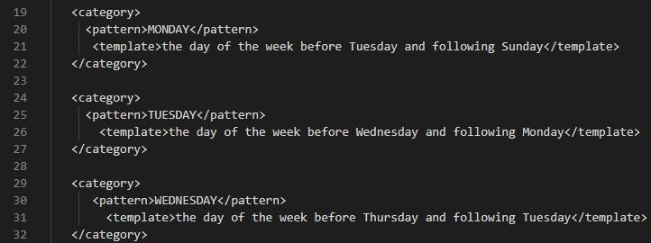

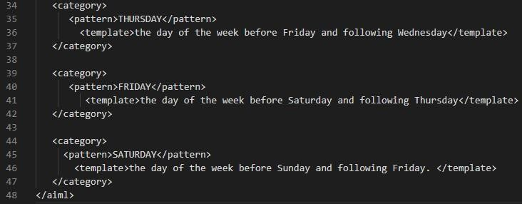

Ouput:

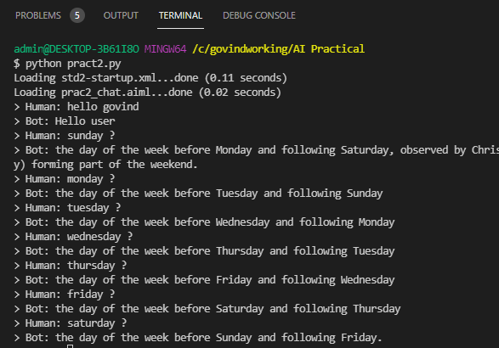

# PRACTICAL:3

AIM : Implement Bayes Theorem Using Python. Code:

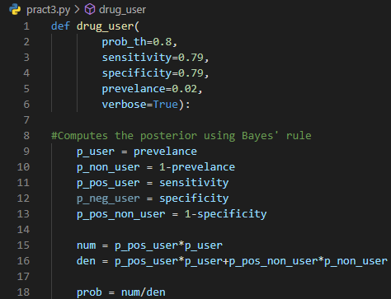

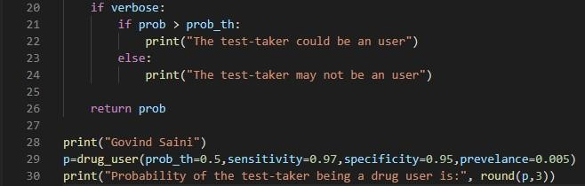

Ouput:

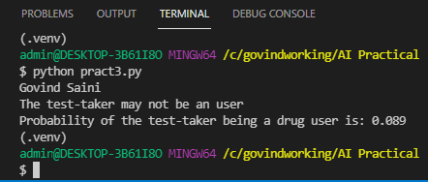

# PRACTICAL:4

AIM : Implement Conditional Probability And Joint Probability. Using Python.

Code:

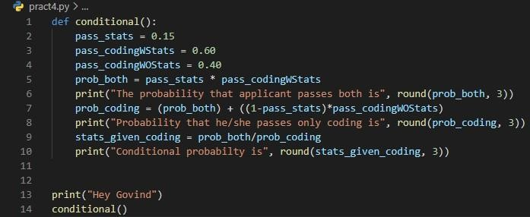

Ouput:

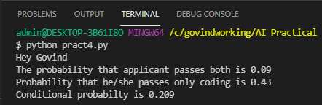

Code:

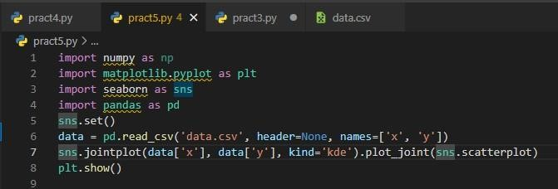

Output:

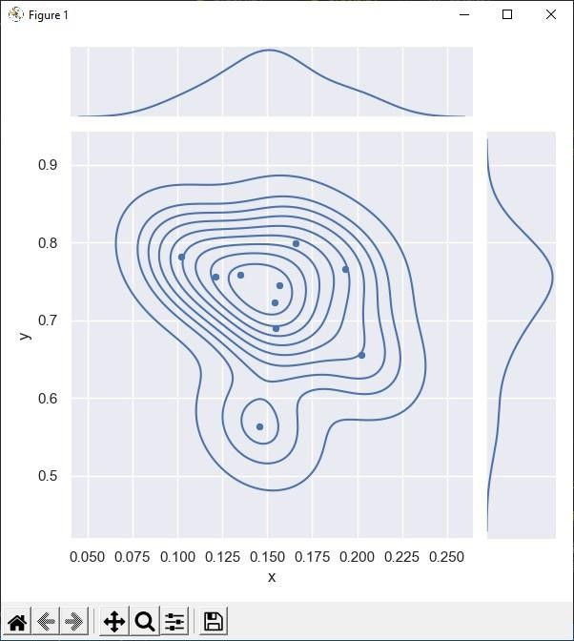

# PRACTICAL:5

AIM : A Program To Implement Rule Based System. Code:

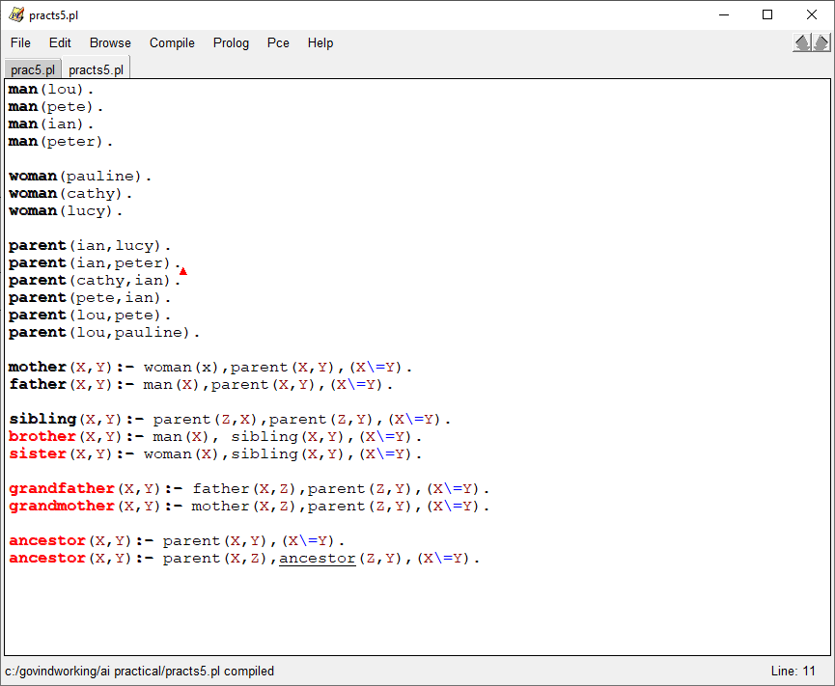

Ouput:

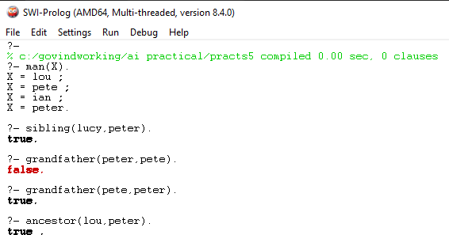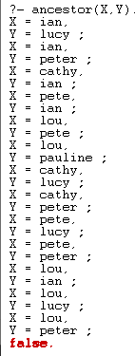

# PRACTICAL:6

AIM : Design A Fuzzy Based Application Using Python.

Code:

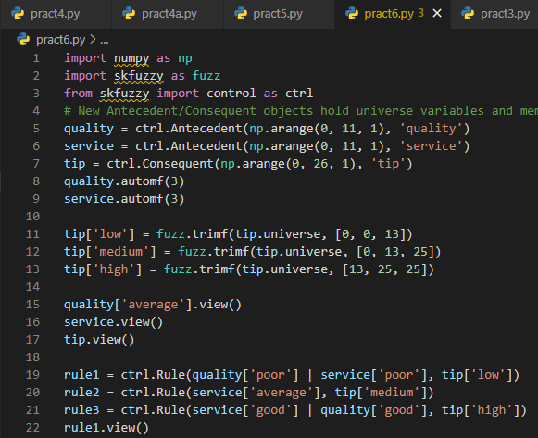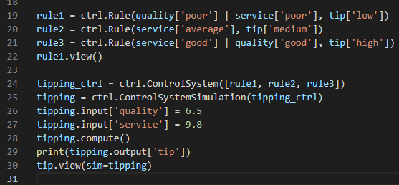

Ouput:

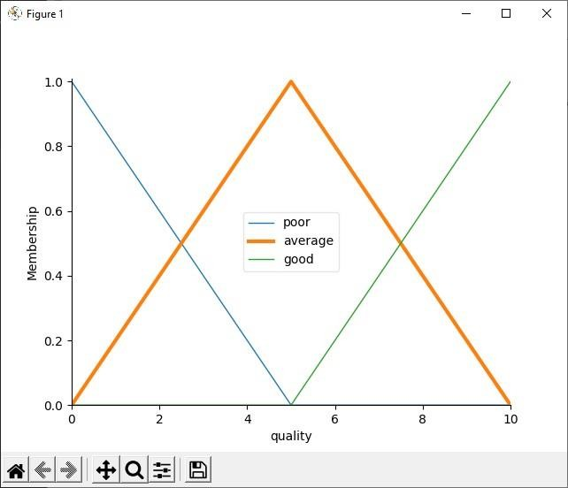

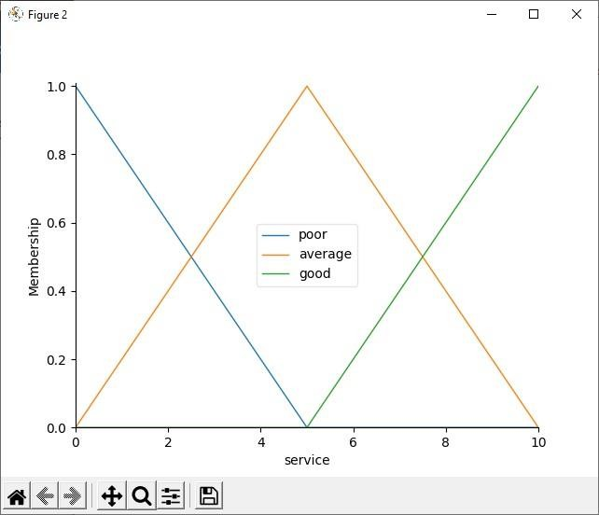

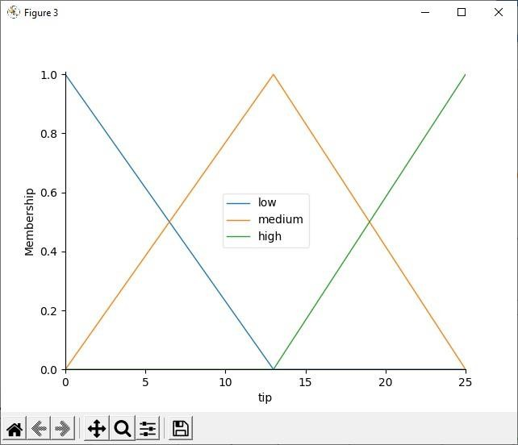

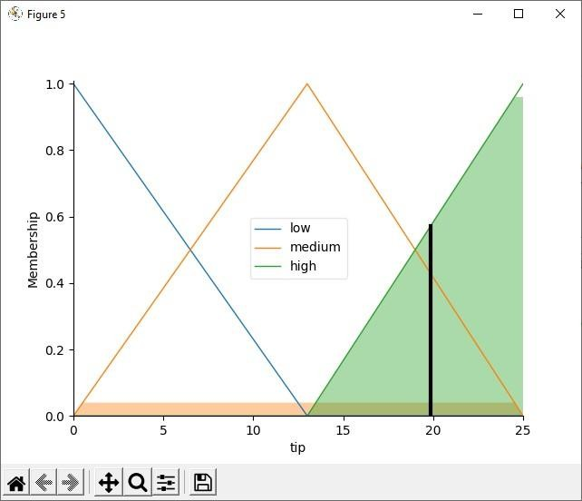

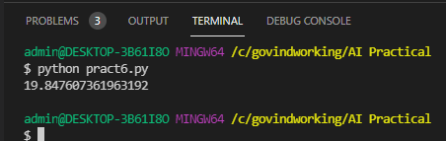

# PRACTICAL:7

AIM : Write And Application To Stimulate Supervised And Un-Supervised Learning Model.

Code:

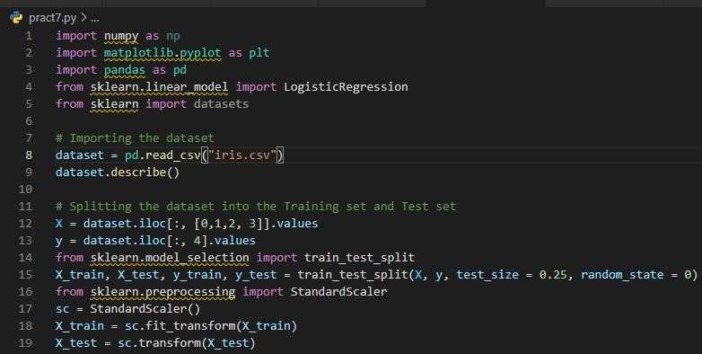

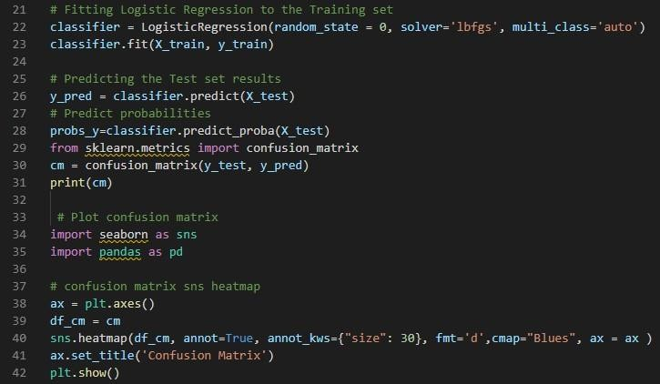

Ouput:

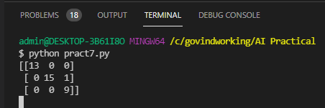

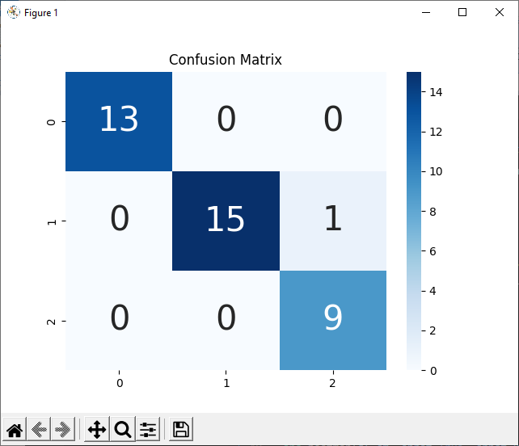

Code:

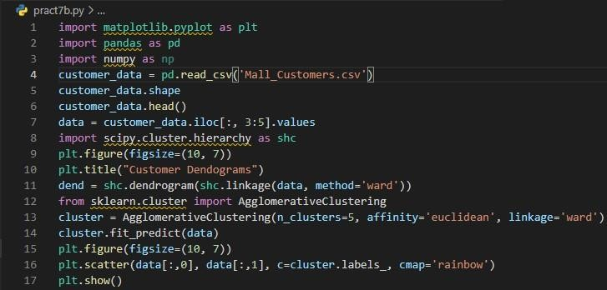

Ouput:

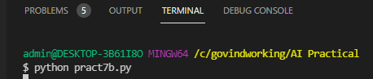

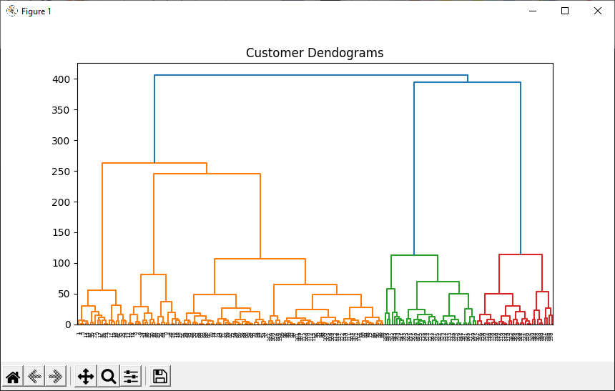

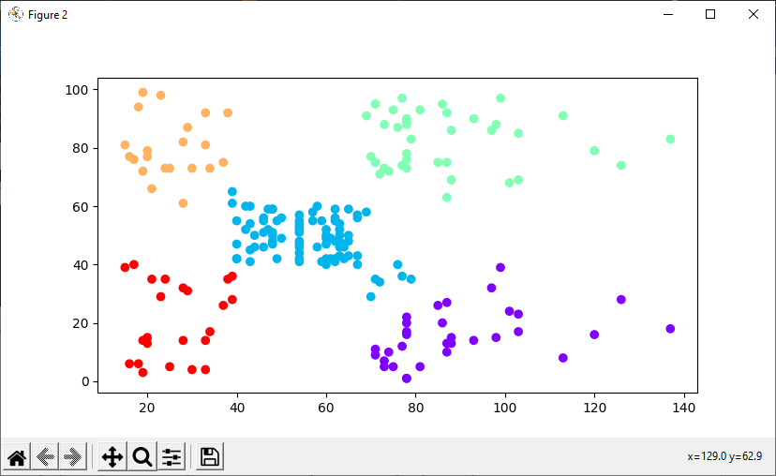

PRACTICAL:8

AIM:Write An Application To Implement Clustering Algorithm.

Code:

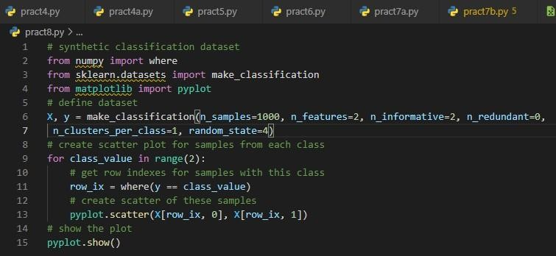

Ouput:

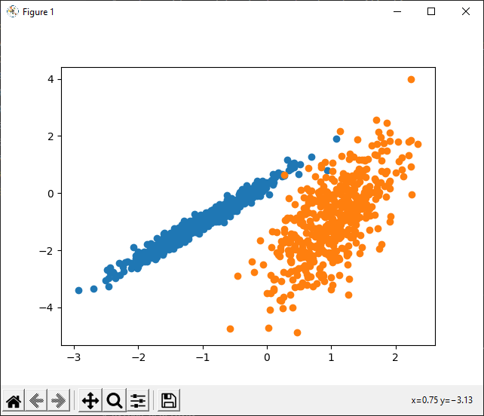

# PRACTICAL: 9

AIM:WriteAnProgramToImplement BFSAlgorithm. Code:

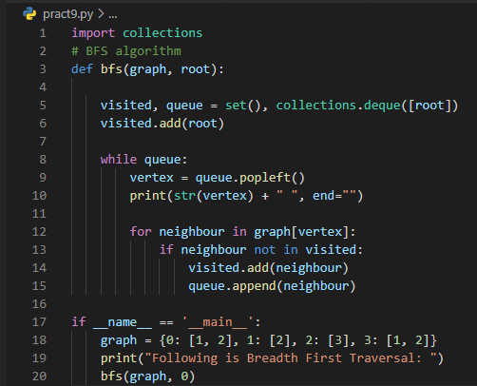

Output:

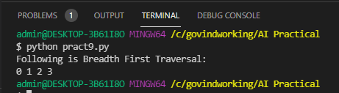

# PRACTICAL:10

AIM : Write An Program To Implement DFS Algorithm. Code:

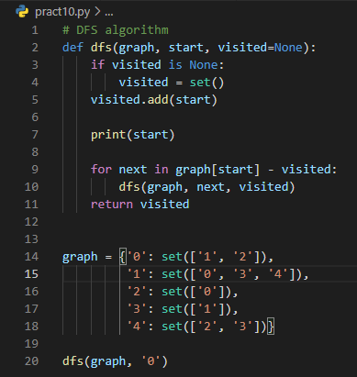

Output:

